Last Updated: 28-10-2024
Version: 1.0
Created by: Aditya Mourya
Department:
Audience: IT Administrators, Security Administrators, Office 365 Admins

Title: Microsoft Defender for Office 365 - Overview and Setup Guide

Overview
Microsoft Defender for Office 365 is a cloud-based security solution designed to protect your organization’s email and collaboration tools from a range of threats such as phishing, malware, business email compromise (BEC), and other malicious activities. Integrated with Microsoft 365, Defender for Office 365 provides advanced threat protection (ATP) features that safeguard your users from attacks targeting their mailboxes, SharePoint, OneDrive, and Teams environments.
With Microsoft Defender for Office 365, administrators can use robust security features to detect, investigate, and respond to potential threats, helping to reduce the risk of data breaches and improve organizational security.

Key Features of Microsoft Defender for Office 365
- Safe Attachments:
  - Scans email attachments in real time for potential malware or other malicious content. If an attachment is found to be malicious, it is automatically quarantined to prevent harm.
  - Protects against zero-day threats and unknown malware that bypass traditional signature-based antivirus software.
- Safe Links:
  - Scans URLs in emails and documents, providing protection from malicious or harmful links. If a user clicks on a malicious link, they are redirected to a warning page, or the link is blocked entirely.
  - Dynamic real-time protection that ensures links are always evaluated for safety when clicked, even after the email is delivered.
- Anti-Phishing Protection:
  - Detects and blocks phishing attempts, including spear-phishing and business email compromise (BEC). Uses machine learning models to identify suspicious behaviours and impersonation attempts.
  - Provides end-user warnings about potentially dangerous emails or fraudulent messages.

- Anti-Spam and Anti-Malware:
  - Automatically filters spam, junk mail, and malicious emails using industry-leading detection algorithms.
  - Quarantines or removes messages that contain known malware or phishing attempts.
- Threat Investigation and Response:
  - Provides administrators with powerful tools for threat hunting and investigation within Microsoft 365 Defender. Admins can view alerts, run investigations, and trigger automated responses.
  - Enables detailed reports and dashboards to track the progress of investigations.
- Security Policies:
  - Allows organizations to configure security policies for email protection, including quarantine settings, custom rules, and report delivery.
- Integration with Microsoft 365 Defender:
  - Seamlessly integrates with Microsoft 365 Defender for cross-platform visibility and enhanced threat detection. Provides a unified experience across endpoint, identity, and email security.

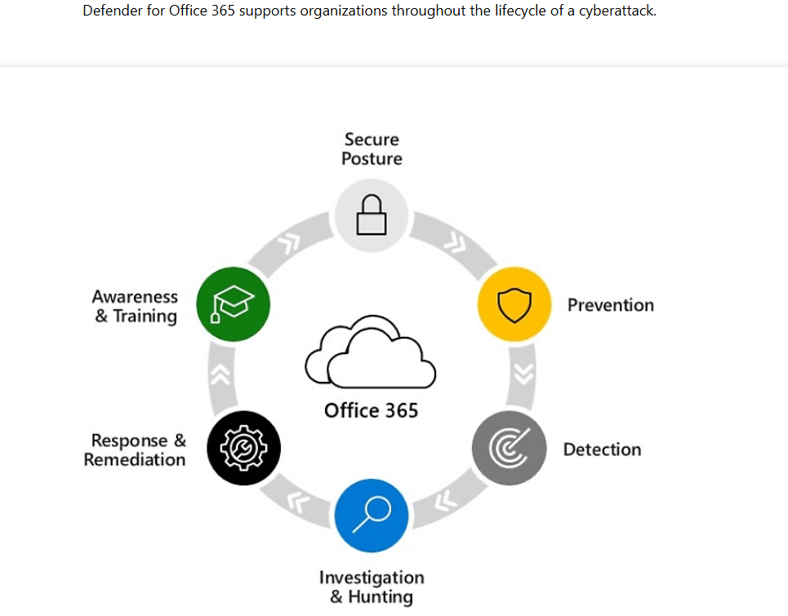

How to Set Up Microsoft Defender for Office 365

Purpose:
This Standard Operating Procedure (SOP) outlines the steps to enable Microsoft Defender for Office 365 to enhance email security and protect against advanced threats such as phishing, malware, and business email compromise (BEC).

Scope:
This SOP applies to IT administrators responsible for configuring security settings in Microsoft 365 and enabling Microsoft Defender for Office 365 for an organization.

Prerequisites:
- Microsoft 365 tenant with appropriate admin privileges (Global Administrator, Security Administrator, or Exchange Administrator).
- Microsoft Defender for Office 365 license assigned to relevant users or groups.
- Exchange Online Protection (EOP) and Defender for Office 365 prerequisites met.

Definitions:
- Microsoft Defender for Office 365 (formerly Office 365 ATP): A cloud-based email security service that protects users from malicious emails, attachments, and links.
- Safe Attachments: A feature of Defender for Office 365 that protects users from malicious email attachments.
- Safe Links: A feature that checks and protects users from malicious URLs in email messages.
- Phishing Protection: The ability to detect and block phishing attempts and spoofed emails.

1. Preparation: Review Licensing and Requirements
Ensure that the organization has the appropriate Microsoft Defender for Office 365 plan:
- Microsoft Defender for Office 365 Plan 1 (includes basic protections for email threats).
- Microsoft Defender for Office 365 Plan 2 (includes advanced threat protection and automated investigation capabilities).
Verify that the Microsoft Defender for Office 365 licenses have been assigned to the required users.

2. Access the Microsoft 365 Defender Portal
- Go to the Microsoft 365 Defender portal and log in using an account with sufficient admin privileges.
- In the left navigation pane, select Email & Collaboration.
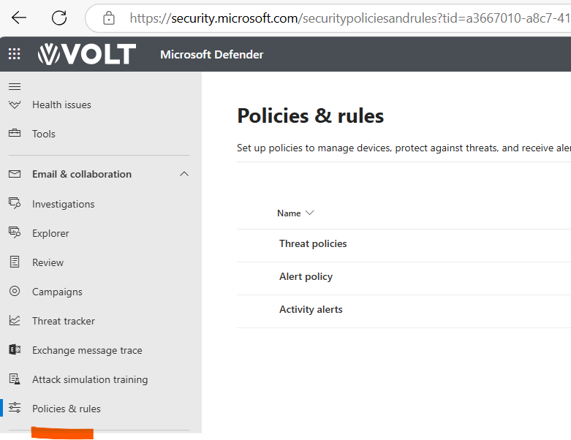

3. Enable Safe Attachments
Safe Attachments helps protect users from potentially malicious attachments in emails.
- From the Email & Collaboration section, click on Policies & rules.
- Under Threat policies, select Safe Attachments.
- In the Safe Attachments section, click + Create policy to create a new policy or select an existing one to modify.
- Choose the desired protection mode:
  - Monitor: Monitor the behaviour without affecting users' actions.
  - Block: Block all malicious attachments.
  - Dynamic Delivery: Allow emails with attachments but delay delivery until the attachment is scanned.
- Configure additional settings (e.g., notifications, apply to specific mailboxes or groups).
- Save the policy.
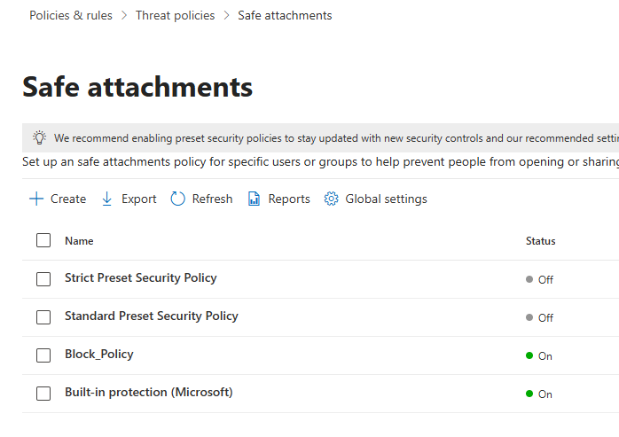

4. Enable Safe Links
Safe Links helps protect users from malicious links in emails by ensuring that links are safe before they are clicked.
- In the Threat policies section, click on Safe Links.
- Click + Create policy to create a new Safe Links policy or select an existing one.
- Configure the policy settings:
  - Protect email messages and Office documents from malicious URLs.
  - Choose to rewrite URLs to route through Defender for Office 365 for scanning.
  - Enable Real-time URL scanning for links that are clicked after receiving the email.
- Set exceptions if needed (e.g., bypass for trusted domains).
- Click Save to apply the policy.
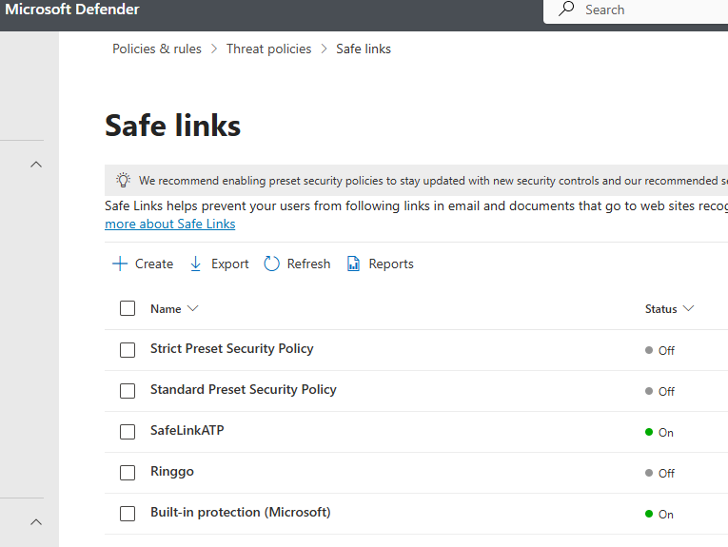

5. Configure Anti-Phishing Protection
Anti-phishing policies help detect and block phishing attempts.
- In the Threat policies section, click on Anti-Phishing.
- Click + Create policy to create a new policy or select an existing one.
- Define the following settings:
  - Policy Name: Give the policy a name.
  - Policy Type: Select whether the policy applies to users or groups.
  - Phishing protection settings: Select protection options like impersonation protection, spoof intelligence, etc.
- Configure Actions on detection (e.g., Quarantine, redirect email, etc.).
- Save the policy.
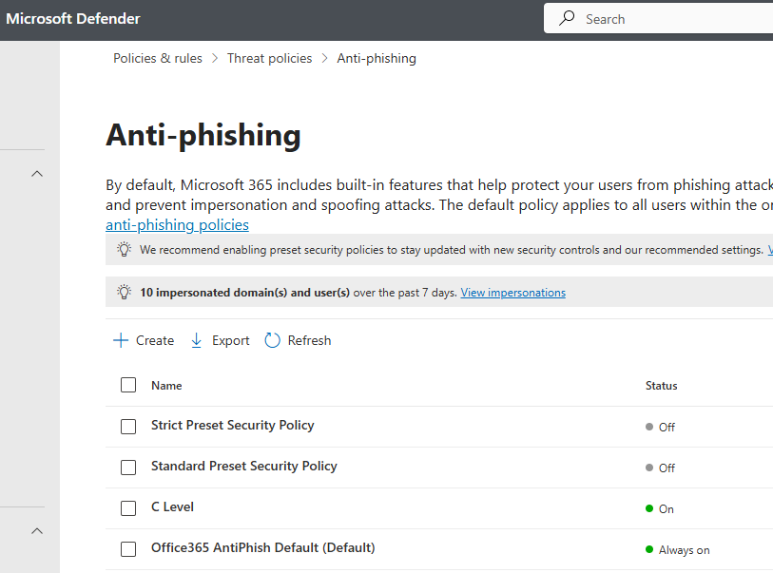

6. Configure Anti-Spam and Anti-Malware Protection
- Ensure that Anti-Spam and Anti-Malware policies are configured properly in the Threat policies section.
- These policies are typically enabled by default but can be customized based on organizational requirements.

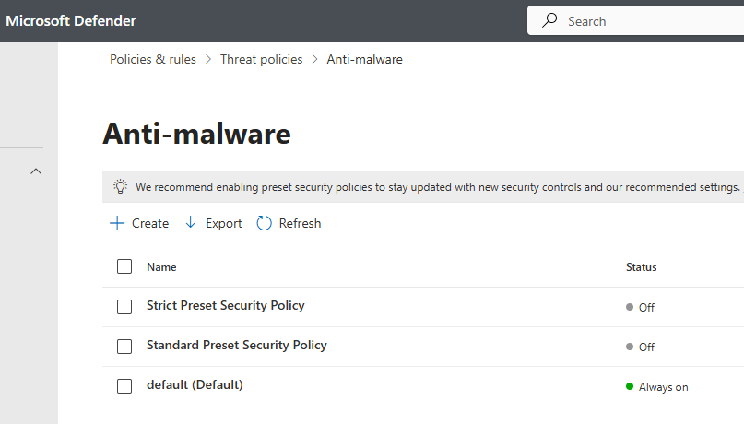

7. Enable and Configure Automated Investigation and Response (AIR)
Microsoft Defender for Office 365 can automatically investigate suspicious activities and take appropriate action.
- In the Microsoft 365 Defender portal, go to Settings>Endpoint>Advance features
- Click to turn on
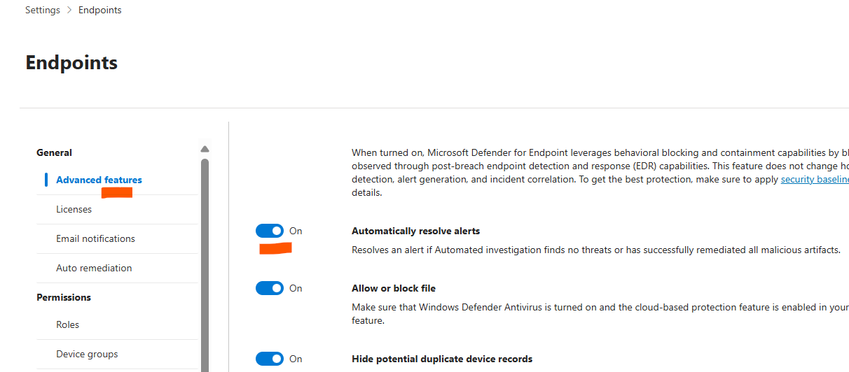

Prerequisites:
Before configuring AIR, ensure the following prerequisites are met:

1. Subscription Requirements:
You need one of the following Microsoft 365 subscriptions:
- Microsoft 365 E5
- Microsoft 365 A5
- Microsoft 365 E3 with the Microsoft 365 E5 Security add-on
- Microsoft 365 A3 with the Microsoft 365 A5 Security add-on
- Office 365 E5 + Enterprise Mobility + Security E5 + Windows E5

2. Network Requirements:
- Microsoft Defender for Identity is enabled.
- Microsoft Defender for Cloud Apps is configured.
- Integration with Microsoft Defender for Identity is required.

3. Windows Device Requirements:
- Windows 10 (version 1709 or later) or Windows 11.
- The following Defender services must be configured:
  - Microsoft Defender for Endpoint
  - Microsoft Defender Antivirus

4. Protection for Email Content and Office Files:
- Microsoft Defender for Office 365 must be configured.

5. Permissions:
To configure AIR, you need the following roles:
- Global Administrator
- Security Administrator
For reviewing, approving, or rejecting actions, refer to the specific permissions for the Action center.

Procedure:

Step 1: Review or Change the Automation Level for Device Groups
The automation level defines whether investigations run automatically and whether remediation actions occur automatically or require approval. The automation level for device groups determines how remediation actions are handled.
Procedure:
- Sign into the Microsoft Defender Portal:
  - Go to Microsoft Defender portal and sign in with your administrator credentials.
- Navigate to Device Groups:
  - Go to Settings > Endpoints > Device groups under Permissions.
- Review Device Group Policies:
  - Look at the Remediation level column to determine the current setting.
  - Recommended Setting: Choose Full - remediate threats automatically for complete automation. This ensures that threats are automatically remediated without requiring manual intervention.
- Create/Edit Device Groups:
  - If necessary, create or edit device groups to match the desired automation level.
  - For further help with this step, refer to How threats are remediated and Create and manage device groups documentation.

Step 2: Review Security and Alert Policies in Microsoft 365 Defender
Review the security and alert policies configured in Microsoft Defender and Office 365 to ensure automated investigation capabilities are correctly configured. Certain alerts can trigger automated investigations, and specific policies in Office 365 need to be set up correctly to enable full automation.
Procedure:
- Review Alert Policies in Defender Portal:
  - Go to the Microsoft Defender portal at https://security.microsoft.com.
  - Navigate to Policies & rules > Alert policy or directly visit Alert policies.
  - Review the Threat management category. Some of the default alert policies here can trigger automated investigation and response actions.
- Security Settings for Email and Content Protection:
  - In Exchange Online Protection (EOP) and Defender for Office 365, ensure Standard and Strict preset security policies are assigned to users.
  - If using custom policies, utilize the Configuration analyzer to compare your policy settings with the recommended Standard and Strict settings for optimal protection.
  - For a detailed listing of settings, refer to Recommended settings for EOP and Defender for Office 365 security.
- Make Necessary Adjustments:
  - Ensure the appropriate alert policies are in place to trigger automated investigations.
  - Review the automated investigation settings in your Defender for Office 365 configuration, as no remediation actions will occur automatically without your approval for email content.

Step 3: Configure Automated Investigation Settings (If Necessary)
You may need to change or fine-tune settings for automated investigations. Depending on your security needs, you can specify automation levels for groups of devices and adjust how investigations and responses are handled.
Procedure:
- Configure Automation Levels for Device Groups:
  - Navigate to Permissions > Endpoints roles & groups > Device groups in the Microsoft Defender portal.
  - Select the device group you want to configure.
  - Under the Automation level setting, ensure that Full - remediate threats automatically is selected, if full automation is desired.
  - If you need to make changes, follow the steps outlined in Create and manage device groups.
- Adjust Remediation Levels:
  - Review the Remediation level for each device group to ensure it is set to the desired level of automation.
  - Repeat this process for all applicable device groups within your organization.

Step 4: Manage and Monitor Remediation Actions in the Action Center
Once your automated investigation and response settings are configured, you can monitor and manage the actions taken by Defender in the Action Center. This is where you can review, approve, or reject remediation actions that have been automatically triggered by the system.
Procedure:
- Access the Action Center:
  - In the Microsoft Defender portal, go to Action Center to view pending remediation actions.
- Review Pending Actions:
  - Review automated actions (such as quarantining or deleting emails) to ensure they align with your security policies.
- Approve or Reject Actions:
  - Approve or reject remediation actions as needed. If the action is appropriate, approve it; if not, reject it for further analysis by the security team.

Next Steps:
After configuring automated investigation and response capabilities, ensure the following:
- Monitor Automated Investigations: Regularly monitor the progress of automated investigations and responses.
- Fine-Tune Policies: Adjust and refine policies based on real-time data and incidents.
- Stay Updated: Keep the Defender and security systems updated to stay ahead of new threats.

Conclusion:
This SOP provides a comprehensive guide to configuring Automated Investigation and Response (AIR) in Microsoft Defender XDR. By following these steps, your organization can automate threat detection, investigation, and remediation, ensuring quicker response times and less reliance on manual intervention. Regular review and adjustment of settings will help maintain effective security operations.

8. Monitor and Review Security Alerts
After enabling Defender for Office 365 features, it is essential to monitor alerts and review reports to track potential threats and false positives.
- In the Microsoft 365 Defender portal, go to Security dashboard to view alerts and insights.
- Regularly check the Threat Explorer for detailed analysis of email threats.
- Set up email notifications to alert admins of security incidents.

9. Communicate with End Users
- Inform users about the new security features being implemented, including Safe Attachments, Safe Links, Anti-Phishing, and Anti-Spam protections.
- Provide guidelines for users to recognize phishing emails and report suspicious emails.
- Ensure they are aware of potential delays in email delivery due to scanning by Defender for Office 365.

10. Periodic Review and Updates
- Regularly review and update policies to ensure they align with the latest security best practices and evolving threats.
- Monitor the effectiveness of Microsoft Defender for Office 365 and adjust settings as necessary.
- Stay informed about updates to Defender for Office 365 features and configurations through Microsoft’s documentation and support channels.

Conclusion:
By following this SOP, IT administrators can successfully enable and configure Microsoft Defender for Office 365 to provide enhanced email security for the organization, safeguarding against a variety of advanced threats including phishing, malware, and other forms of email-based attacks.

Best Practices for Microsoft Defender for Office 365
- Regularly Update Policies:
  - Ensure your ATP policies are always updated to align with the latest threat intelligence from Microsoft.
  - Set up automatic updates or review the security alerts frequently to stay up to date on emerging threats.
- Review Reports and Alerts:
  - Monitor the Security & Compliance Center for alerts and notifications about potential threats or suspicious activities.
  - Customize alert settings to receive real-time notifications for high-priority incidents.
- Enable Multi-Factor Authentication (MFA):
  - Pair Microsoft Defender for Office 365 with multi-factor authentication (MFA) to add an extra layer of security to user accounts.
- Educate Users:
  - Conduct periodic training for employees to help them recognize phishing attempts and avoid clicking on suspicious links or downloading unknown attachments.
  - Encourage users to report suspicious emails using the Report Message add-in in Outlook.
- Automate Responses:
  - Use automated investigations and response (AIR) to quickly mitigate threats once detected. Configure automated actions like quarantining or blocking accounts after a phishing attack is identified.

Troubleshooting
- Issue: Microsoft Defender for Office 365 is not detecting phishing emails.
  - Solution: Ensure that Anti-Phishing policies are configured correctly. Double-check that Impersonation Protection is enabled and regularly review the threat intelligence settings.
- Issue: Users are receiving legitimate emails in quarantine.
  - Solution: Review your Safe Attachments and Safe Links policies to adjust the level of protection. You may need to fine-tune the sensitivity levels to reduce false positives.
- Issue: Delays in processing email alerts or incidents.
  - Solution: Verify that there are no issues with the Defender for Office 365 service. If the delays persist, check the service health dashboard in the Microsoft 365 Admin Centre.

Conclusion
Microsoft Defender for Office 365 is a powerful tool that provides advanced protection against email-based threats like phishing, malware, and business email compromise. By setting up policies, enabling protection features, and following best practices, organizations can ensure their users and sensitive information are secure.
For further assistance, refer to the official Microsoft Defender for Office 365 documentation or contact the IT support team.

End of Article

